**SOCIAL EVENT MANAGEMENT**

**A PROJECT REPORT**

***Submitted by***

**Shraddha Pandya 100300107509**

**Nidhi Joshi 100300107517**

***In fulfillment for the award of the degree***

***Of***

**BACHELOR OF ENGINEERING**

***In***

COMPUTER ENGINEERING



LDRP Institute of Technology and Research, Gandhinagar

**Gujarat Technological University, Ahmedabad**

December, 2013

**LDRP Institute of Technology & Research**



**Social Event Management**

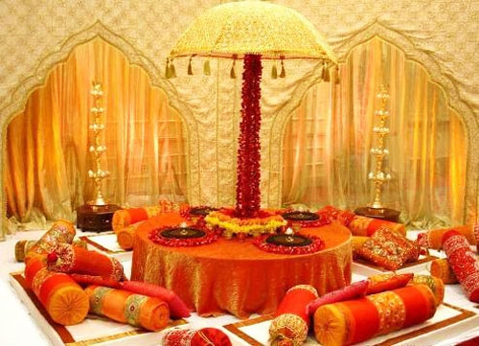

**Presented By:**

* **Shraddha Pandya(100300107509)**
* **Nidhi Joshi (100300107517)**

**Guided By:**

* **Mr. Janak Tank**

**CE-IT Department,**

**LDRP-ITR.**

**LDRP Institute of Technology & Research**

CE-IT Department



**CERTIFICATE**

This is to certify that the Project Work entitled **“Social Event Management”** has been carried out by **Shraddha Pandya(100300107509)** under my guidance in fulfilment of the degree of Bachelor of Engineering in Computer Engineering/Information Technology (8th Semester) of Gujarat Technological University, Ahmedabad during the academic year 2013-14.

**Guides:**

Mr. Janak Tank,

LDRP-ITR

(Internal Guide)

Prof. A. K. Goyal

**Head of the Department**

**LDRP Institute of Technology & Research**

CE-IT Department



**CERTIFICATE**

This is to certify that the Project Work entitled **“Social Event Management”** has been carried out by **Nidhi Joshi (100300107517)** under my guidance in fulfilment of the degree of Bachelor of Engineering in Computer Engineering/Information Technology (8th Semester) of Gujarat Technological University, Ahmedabad during the academic year 2013-14.

**Guides:**

Mr. Janak Tank,

LDRP-ITR

(Internal Guide)

Prof. A. K. Goyal

**Head of the Department**

**Candidate’s Declaration**

We declare that the report entitled “Social Event Management” is our own work conducted under the supervision of the guide **Mr. Janak Tank.**

We further declare that to the best of my knowledge the report for B.E. Seventh semester does not contain part of the work which has been submitted for the award of B.E. Degree either in this or any other university without proper citation.

Candidate’s Signature

Candidate’s Name: Ms. SHRADDHA PANDYA

Candidate’s Signature

Candidate’s Name: Ms. NIDHI JOSHI

**Mr. JANAK TANK**

CE – IT Department,

LDRP Institute of Technology and Research – Gandhinagar.

**Acknowledgement**

In many ways it is, more difficult to acknowledge one’s but I express my deep sense of gratitude to each and every one whose support and co-operation helped me to complete this project successfully, and without which the completion of this project would ever have been easier.

I hereby take the pleasure of thanking my project guide. I have truly benefited a lot from the constructive criticism and suggestions given to me by Mr. JANAK TANK. Here are some special thanks to few special people whose co-operation made this work really special.

Acknowledgements and thanks are also extended to all the authors whose articles have been referred to for the completion of this report.

By,

Shraddha Pandya,

Nidhi Joshi.

**ABSTRACT**

Social Event Management (SEM) is the system which is completely based on arranging social events. This system is best for people to organize any event without any type of tension. There is so many of people who are willing to organize amazing event, but they fear of frustrating and managing process. For them SEM system is the best solution.

The basic idea behind Social Event management system is the applying a proper management to the creation and development of festivals and events. The whole system consists of mainly four entities. The Social Event management is the process of planning a marriage ceremony, festival, engagement ceremony, Birthday party.

The first entity of Admin manages all the agents and provides services like handle the account of the agents. Second entity of Client they can access the services of the agents by filling up some information. The third entity is agent they are registered in our site for provide their services to the users who are interested to take those services .and last entity of guest they are visited the site and review the site. The Admin is to manage all the registered agents and provided the change of profile of agent and provide to other services like to handle the record of all agents. Admin to be get the report. The clients are chosen the registered agents and booking the services. The client to be filled the information. Agents (Vendors) are registered in our site for provide their services to the users who are interested to take those services. Manage all the service, Functions are to be updated, inserted, deleted the record. Guest they are visited the site and review the site.

**LIST OF FIGURES:**

|  |  |  |
| --- | --- | --- |
| **Figure number** | **Description** | **Page number** |
| FIGURE 4.1 | WATERFALL MODEL | 4-2 |
| FIGURE 4.2 | PROTOTYPE MODEL | 4-4 |
| FIGURE 4.3 | CLASS DIAGRAM | 4-5 |
| FIGURE 4.4 | GENERAL USE CASE SYSTEM | 4-6 |
| FIGURE 4.5 | E-R DIAGRAM | 4-7 |
| FIGURE 4.6 | DATA FLOW LEVEL-0 | 4-8 |
| FIGURE 4.7 | DATA FLOW LEVEL-1(1) | 4-9 |
| FIGURE 4.8 | DATA FLOW LEVEL-1(2) | 4-10 |
| FIGURE 4.9 | DATA FLOW LEVEL-1(3) | 4-11 |
| FIGURE 4.10 | DATA FLOW LEVEL-1(4) | 4-12 |
| FIGURE 4.11 | DATA FLOW LEVEL-2(1) | 4-13 |
| FIGURE 4.12 | DATA FLOW LEVEL-2(2) | 4-14 |
| FIGURE 4.13 | DATA FLOW LEVEL-2(3) | 4-15 |
|  |  |  |
| FIGURE 4.14 | SEQUENCE FOR ADMIN | 4-16 |
| FIGURE 4.15 | SEQUENCE FOR CLIENT | 4-17 |
| FIGURE 4.16 | SEQUENCE FOR AGENT | 4-18 |
| FIGURE 4.17 | SEQUENCE FOR GUEST | 4-19 |
| FIGURE 4.18 | ACTIVITY FOR ADMIN | 4-20 |
| FIGURE 4.19 | ACTIVITY FOR CLIENT | 4-21 |
| FIGURE 4.20 | ACTIVITY FOR AGENT | 4-22 |
| FIGURE 4.21 | ACTIVITY FOR GUEST | 4-23 |
|  |  |  |
| FIGURE 5.1 | SYSTEM FLOW CHART | 5-1 |

**LIST OF TABLES:**

|  |  |  |
| --- | --- | --- |
| **Table number** | **Description** | **Page number** |
| TABLE 1 | CUSTOMER REGISTRATION | 5-3 |
| TABLE 2 | EVENT LOCATION | 5-3 |
| TABLE 3 | ORDER DETAILS | 5-3 |
| TABLE 4 | SCHEDULE | 5-4 |
| TABLE 5 | AGENT DETAILS | 5-4 |
| TABLE 6 | STATE | 5-4 |
| TABLE 7 | CITY | 5-4 |
| TABLE 8 | BOOKING | 5-5 |
| TABLE 9 | PAST EVENTS | 5-5 |
| TABLE 10 | VIDEOS | 5-5 |
| TABLE 11 | LOGIN | 5-5 |
| TABLE 12 | TIPS | 5-6 |
| TABLE 13 | PROVIDED SERVICES | 5-6 |
| TABLE 14 | CONTACT | 5-6 |
| TABLE 15 | FEEDBACK | 5-6 |

**TABLE OF CONTENTS:**

|  |  |  |  |
| --- | --- | --- | --- |
| **Sr. No. :** | **Title** | | **Page no.** |
|  | Acknowledgement | |  |
|  | Abstract | |  |
|  | List of Figures | |  |
|  | List of Tables | |  |
|  | Symbols and Abbreviations | |  |
|  | Table of Contents | |  |
| **1.** | **INTRODUCTION** | |  |
|  | 1.1 | Introduction | 1-1 |
|  | 1.2 | Scope | 1-1 |
|  | 1.3 | Project summary and Purpose | 1-1 |
|  | 1.4 | Overview of the project | 1-2 |
|  | 1.5 | Problem definition | 1-2 |
| **2.** | **TECHNOLOGY AND LITERATURE REVIEW** | |  |
|  | 2.1 | About Tools And Technology | 2-1 |
|  | 2.2 | History of Work Done | 2-1 |
|  | 2.3 | Objectives of the system | 2-1 |
| **3.** | **System Requirements Study** | |  |
|  | 3.1 | User Characteristic | 3-1 |

|  |  |  |  |  |  |  |
| --- | --- | --- | --- | --- | --- | --- |
| **Sr. No. :** | **Title** | | | | | **Page no.** |
| **3.** | 3.2 | | Hardware and Software Requirements | | | 3-1 |
|  | 3.3 | | Constraints | | | 3-2 |
|  |  | | 3.3.1 | | Hardware Limitations | 3-2 |
|  | 3.3.2 | | Functional Requirements | 3-2 |
|  | 3.3.3 | | Performance Requirements | 3-3 |
|  | 3.3.4 | | Reliability Requirements | 3-3 |
|  | 3.3.5 | | Safety and Security Consideration | 3-4 |
|  | 3.4 | | Assumptions and Dependencies | | | 3-4 |
| **4.** | **System Analysis** | | | | |  |
|  | 4.1 | Study of Current System | | | | 4-1 |
|  | 4.2 | Problem and Weaknesses of Current System | | | | 4-1 |
|  | 4.3 | Feasibility Study | | | | 4-1 |
|  | 4.4 | Activity/Process In New System | | | | 4-2 |
|  | 4.5 | Class Diagram | | | | 4-5 |
|  | 4.6 | System Activity | | | | 4-6 |
|  | 4.6.1 | | USE CASE DIAGRAM | | 4-6 |
|  | 4.6.2 | | E-R DIAGRAM | | 4-7 |
|  | 4.6.3 | | DATA FLOW DIAGRAM | | 4-8 |
|  | 4.6.4 | | SEQUENCE DIAGRAM | | 4-16 |
|  | 4.6.5 | | ACTIVITY DIAGRAM | | 4-20 |
| **5.** | **System Design** | | | | |  |
|  | 5.1 | SYSTEM FLOW CHART | | | | 5-1 |
|  | 5.2 | DATA DICTIONARY | | | | 5-3 |
| **6.** | **User Interface View** | | | | |  |
|  | 6.1 | CLIENT PANEL VIEW | | | | 6-1 |
|  | 6.2 | ADMIN PANEL VIEW | | | | 6-11 |
| **7.** | **Drawbacks and Future enhancement** | | | | | 7-1 |
| **8.** | **Conclusion** | | | | | 8-1 |
| **9.** | **Bibliography** | | | | | 9-1 |

1. **INTRODUCTION**
   1. **INTRODUCTION:**

Our system provides the effective plan to people for their functions wedding, birthday party, anniversary or baby shower party just as you wants it. We aim to serve you the best and you will agree with us the moment you receive a response from our experts. Make a phone call and start talking right away to one of our professionals or Let Us Know Your Preferences & allow us to help you find the perfect party event!

The system contains the different functions and regarding their services provided by the vendors who are registered in our system they are provide the services like user select the services book that services and select the product or the thing which they want to buy.

**1.2 SCOPE:**

* System support the customers to arrange their events at best prices, facilities with saving time
* Also gives tips to arrange events by them salves
* Decrease the frustration
* Easily available information of all kind of places, foods , sounds and themes
* Including open event arranging tips for public

**1.3 Project summary and Purpose:**

The main purpose of our system is to make easy to which can be used for all of the internet users, who have internet connections. This application will provide to the user to better planning for their functions .This application provides the services related to functions .The requirements that are stated in this document will determine the final product and its functionality .This document serves as the unambiguous guide for the developers of this software system.

**1.4 Overview of the project:**

The basic idea behind Social Event management system is the applying a proper management to the creation and development of festivals and events. Social Event management is the process of planning a marriage ceremony, festival, engagement ceremony, Birthday party.

**1.5 Problem definition:**

Social Event management system is the applying a proper management to the creation and development of festivals and events.

* **Modules :**
  + - Schedule
    - Location
    - Food ,Music ,Decoration Services
    - Booking
    - Tips
    - Feedback

**2. TECHNOLOGY AND LITERATURE REVIEW**

**2.1 About Tools and Technology:**

**Tools:**

Oracle, Eclipse, Tom cat server

**Technology:**

JAVA, HTML5, Bootstrap, JAVA SCRIPT, CSS3

**2.2 History of Work Done:**

Prepared plan for designing system of social event management. Through the report made the concrete figure of system which we are going to ready. With the help of data dictionary, diagrams and preparing system requirements study we got the perfect approach to clearer view of system. We had gathered all the information about to how system will be built up and how it will work.

**2.3 Objectives of the system:**

* To provide the information regarding **to any event.**
* To provide the information about the **Booking of users choice.**
* Online Users can submit their queries by giving the wedding destination, tentative date, number of guests, contact number etc.
* Interested Users can book accommodations for their guests in Hotels. It can be a 5 Star, 4 Star or 3 Star hotel. Online users can provide their requirements like no. of rooms, no. of nights, accommodation budget etc.
* There is a facility to book caterers according to the budget. Different plans are available by the caterers; these are Economy, Gold, Platinum and Silver.
* Mailing facility to reply clients.
* Different venues are available for the choices.

Availability of Wedding cards, Wedding cakes, Wedding dresses, Transport, Flower Decoration etc.

* To provide the functionality of **online Booking and Cancellation.**
* To provide the information of **status of catering, facilities available.**
* To provide the facility to maintain the records of users.

**3. System Requirements Study**

**3.1 User Characteristic:**

There are three types of user in Social event management system.

(1) Administrator

(2) Agents (Vendors)

(3) Clients

(4) Guests / Visitors

**3.2 Hardware and Software Requirements:**

**Hardware:**

-Processor: Standard processor with a speed of 1.6 GHZ or more.

-Memory: 4 GB

-RAM: 256 MB or more.

-Hard disk: 20 GB or more

-Monitor: Standard colour.

-Keyboard: Standard Monitor.

-Mouse: Standard Mouse.

**Software:**

-Front End: Java, Java Script, JQuery, CSS

-Back End: Oracle

-Microsoft visual studio 2007

-Tools: Macromedia Dreamweaver 8, Web browser, Photoshop

-OS: Windows 7

* 1. **Constraints :**

**3.3.1 Hardware Limitations:**

* If there is perfect tested computer available then there is no limitations related to hardware.

**3.3.2 Functional Requirements:**

|  |  |  |
| --- | --- | --- |
| **Req #** | **Description** | **Priority** |
| **REQ-1** | User will login into the system and buy the products of their interest. | [Priority = High] |
| **REQ-2** | If user is not a registered user then user first have to sign up for the system and then he will be able to use the features of it. | [Priority = High] |
| **REQ-3** | The user will be able to select the functions | [Priority = medium |
| **REQ-4** | The user will be able to search for products through a standardized screen. Advanced options will be available by clicking appropriate links. | [Priority = High] |
| **REQ-5** | The person can get the information provide the news flash. In this feature if vender’s address is change or any discount or offers are there then new address, offers are flash in the news. | [Priority = Medium] |
| **REQ-6** | The user will be able to keep the products in the shopping cart if they are not able to buy that product for that particular point of time. | [Priority = Low] |

## **Result Browsing Feature**

* **Description and Priority**

After a user performs a search, their search results are displayed. The object of this feature is to display the products which match the desires the user expressed during the search. In turn the user should select a product in order to proceed to buy that product.

* **Functional Requirements**

|  |  |  |
| --- | --- | --- |
| **Req #** | **Description** | **Priority** |
| **REQ-1** | The user will view the results of the search performed in a graphical-tabular-like format. | [Priority = High] |
| **REQ-2** | The user will be able to sort the results by price, purchase date and purchase time. | [Priority = High] |
| **REQ-3** | The user will be able to choose the products from the list of available products. | [Priority = High] |
| **REQ-4** | When the user selects a particular product the system will send the selected product or service to add to cart. | [Priority = High] |

**Other Non-Functional Requirements:**

**3.3.3 Performance Requirements:**

All Web pages generated by the system shall be fully downloadable in no more than 10 seconds over a 40KBps modem connection. Responses to queries shall take no longer than 10 seconds to load onto the screen after the user submits the query. The system shall display confirmation messages to users within 4 seconds after the user submits information to the system.

**3.3.4 Reliability Requirements:**

The system shall operate 95% of the time. The number of defect should not exceed 10 per function. In addition, before the submission of the final release the calendar must be tested in case of the defect over 10 per function.

**3.3.5 Safety and Security Consideration:**

* **The security measures have been taken in a bid to make the software full proof in terms of various activities:-**
* Input Validations of the forms.
* Output Validations of the result.
* Login timing to maintain the Session management.
* Logout timing of the user
* Data Security
* Software Security
* Hardware Security
* Illegal copying should be restricted

* These are the few measures that are taken into account to meet the security measures while developing a project for an organization.

Users shall be required to log in to the system for their own reservation information and modification with e-mail address and password. The system shall permit only authorized members who are on the list of authorized Menu Managers to do administrator’s task. The system shall permit customers to view only their own previously placed orders, not orders placed by other customers.

**3.4 Assumptions and Dependencies:**

* The user should have sufficient knowledge about computers.
* The computer should have internet connection and Internet server capabilities.
* The users know the English language, as the interface will be provided in English.

**4. System Analysis**

**4.1 Study of Current System:**

The problems discussed below needs to be addressed which will lead to a more user friendly, easy to use and widely compatible product. The interface makes it difficult to use the product. It consumes more time than reducing effort. This may discourage people to use this product. The software are used to reduce effort and increase efficiency but due to the above problems it may decrease efficiency.

So the product should be such that no training should be necessary. Thus it should have an easy to use interface. Also templates should be editable and reprint facility should be available. Also should be able to access his information from anywhere. Export facility should be present. It should be LAN compatible.

**4.2 Problem and Weaknesses of Current System:**

* The features are arranged in such a manner that it becomes difficult to navigate from one place to another.
* If persons want to celebrate any function and arrange the facilities related to that then they have to go at the particular place for book or purchase that thing.
* It is very time consuming process in the system.
* Many websites are also available who don’t provide all facilities or for all type of functions.
* The users cannot get all the services as per their mind.
* The users cannot get the facilities like upload their photos and feedback for the system
* The system is not provide the match maker and policy services.

**4.3 Feasibility Study:**

Types of the Feasibility Study:

* Operational Feasibility
* Technical Feasibility
* Economic Feasibility
* Schedule Feasibility
* Implementation Feasibility

Through the implementation of following steps we can get the above five feasibility in our system means our system is feasible in real world. Innovations/Solutions adopted for above discussed problem are:-

* Website from where the users can access agent’s data from anywhere
* Color coding are provide to every product so that the matching of the different clothes, footwear, ornaments.
* An easy to use interface
* Multi-user and LAN compatible
* Export details and report facility
* Policy Facility
* Tips for guest facility
* FAQ facility
* Online purchase of product

**4.4 Activity/Process in New System:**

**Project Development approach and justification:-**

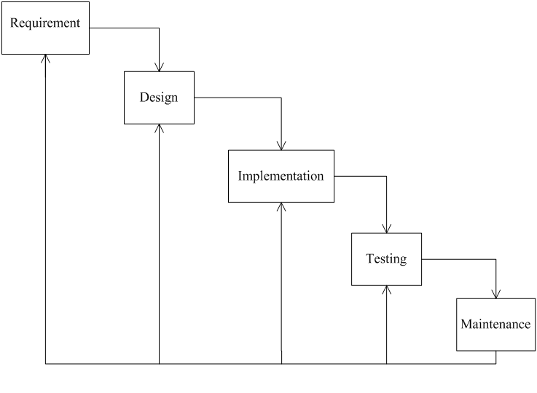 **FIGURE.4.1. WATERFALL MODEL**

Sometimes called the classic life cycleor the Iterative waterfall model,the linear sequential modelsuggests a systematic, sequential approach5 to software development that begins atthe system level and progresses through analysis, design, coding, testing, and support.

Modeled after a conventional engineering cycle, the Iterative Waterfall model encompasses the following activities.

System/information engineering and modeling:

- Because software is always part of a larger system (or business), work begins by establishing requirements for all system elements and then allocating some subset of these requirements to software.

Software requirements analysis:

- The requirements gathering process is intensified and focused specifically on software.

Design:-Software design is actually a multistep process that focuses on four distinct attributes of a program: data structure, software architecture, interface representations, and procedural (algorithmic) detail.

Code generation:

-The design must be translated into a machine-readable form. The code generation step performs this task. If design is performed in a detailed manner, code generation can be accomplished mechanistically.

Testing:

-Once code has been generated, program testing begins. The testing process focuses on the logical internals of the software, ensuring that all statements have been tested, and on the functional externals.

Support:

-Software will undoubtedly undergo change after it is delivered to the customer (a possible exception is embedded software). Software support/maintenance reapplies each of the preceding phases to an existing program rather than a new one.

**Another important model that help to update system**

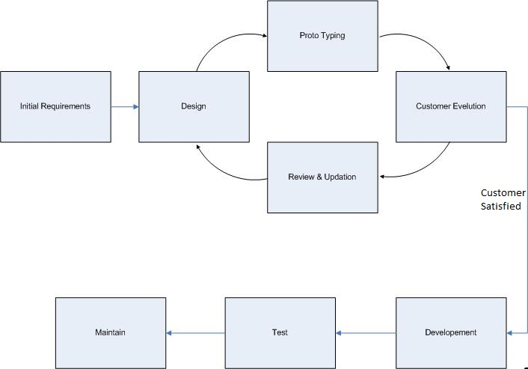

**FIGURE 4.2 PROTOTYPE MODEL**

The process model used will be prototype model as the software will be updated according to the needs and requirements of the user.

The Software Prototyping refers to building software application prototypes which display the functionality of the product under development but may not actually hold the exact logic of the original software.

Software prototyping is becoming very popular as a software development model, as it enables to understand customer requirements at an early stage of development.

It helps get valuable feedback from the customer and helps software designers and developers understand about what exactly is expected from the product under development.

Prototype is a working model of software with some limited functionality. The prototype does not always hold the exact logic used in the actual software application and is an extra effort to be considered under effort estimation. Prototyping is used to allow the users evaluate developer proposals and try them out before implementation.

It also helps understand the requirements which are user specific and may not have been considered by the developer during product design.

**4.5 Class Diagram:**

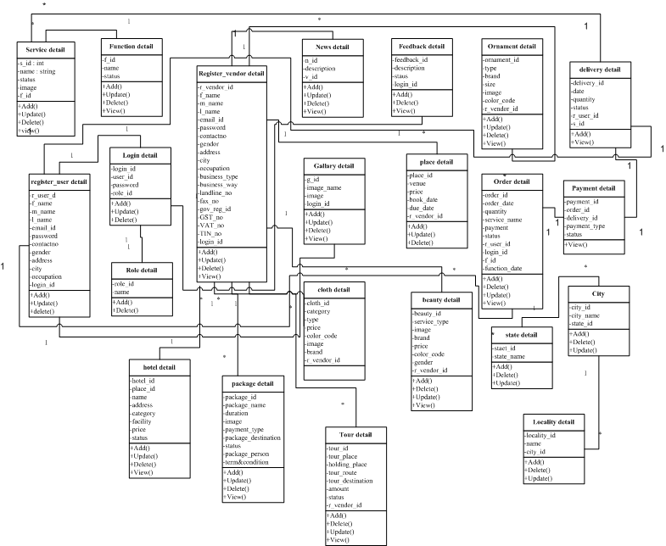

**FIGURE 4.3 CLASS DIAGRAM**

**4.6 System Activity:**

4.6.1 USE CASE DIAGRAM:-

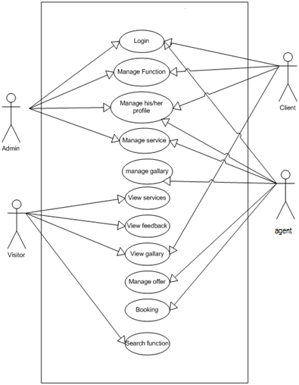

FIGURE 4.4 GENERAL USE CASE SYSTEM

**4.6.2 E-R DIAGRAM:-**

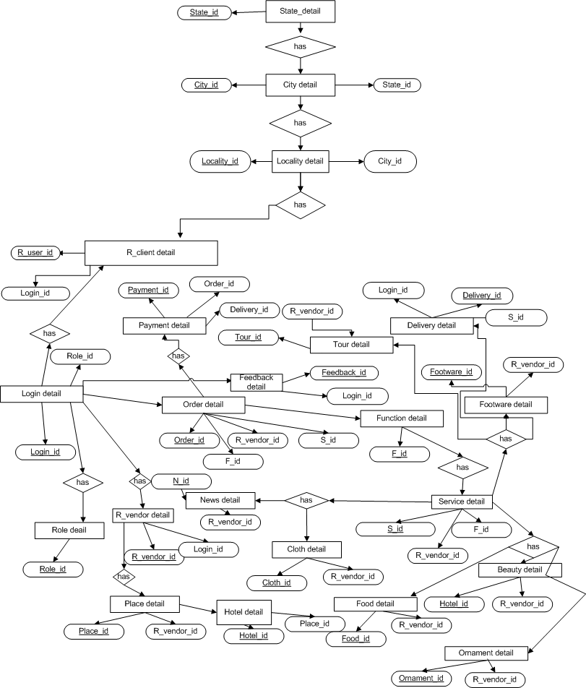

FIGURE 4.5 E-R DIAGRAM

**4.6.3 DATA FLOW DIAGRAM:-**

**LEVEL: 0**

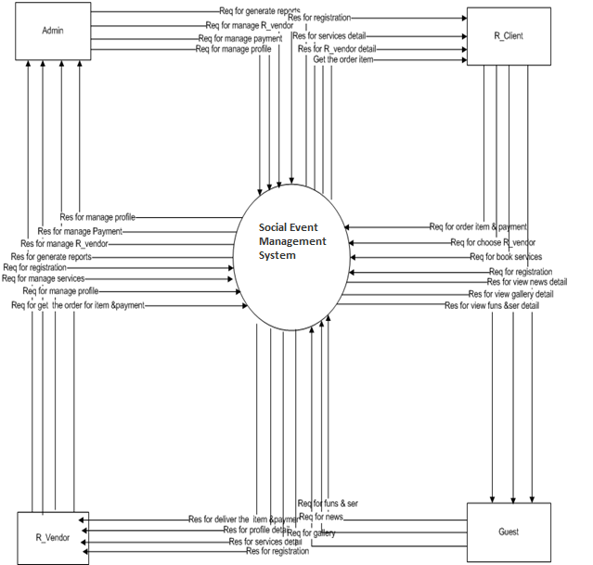

FIGURE 4.6 CONTEXT LEVEL DFD

**LEVEL: 1(1)**

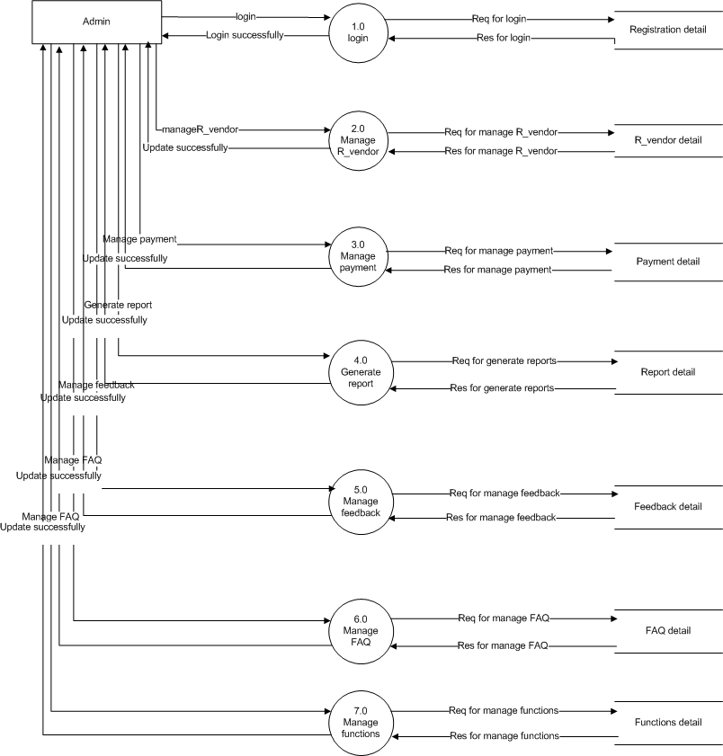

**FIGURE 4.7 LEVEL-1 ADMIN DFD**

LEVEL: 1(2)

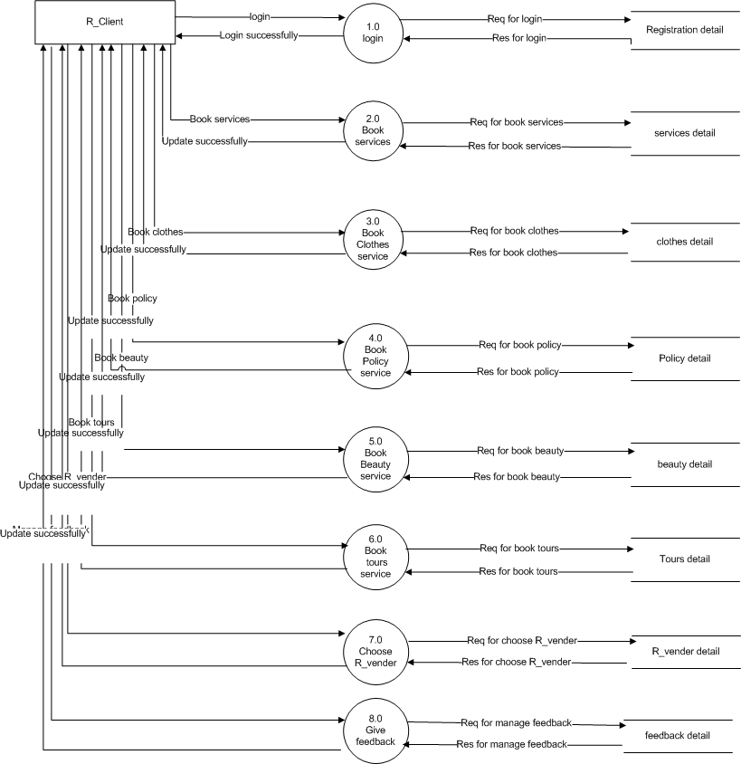

FIGURE 4.8 LEVEL-1 R_CLIENT DFD

LEVEL: 1(3)

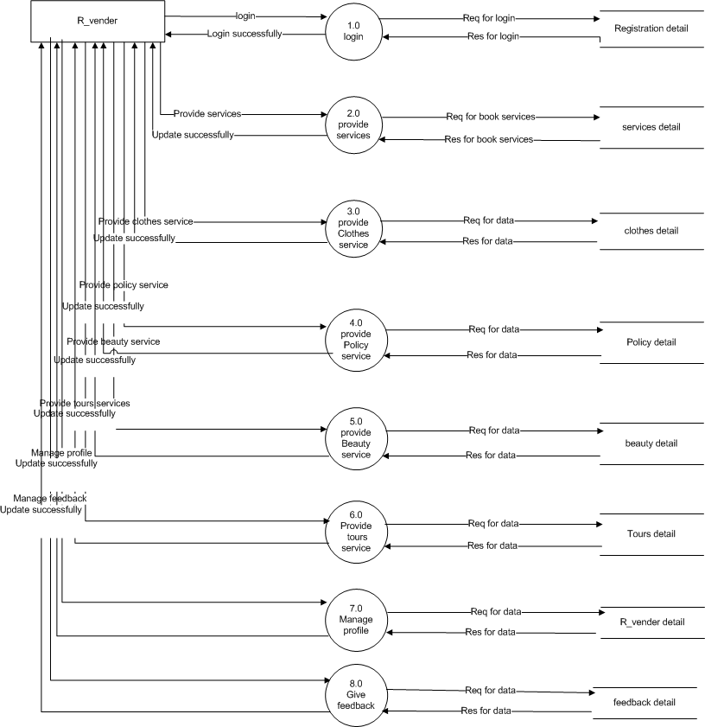

FIGURE 4.9 LEVEL-1 R_VENDOR DFD

LEVEL:1(4)

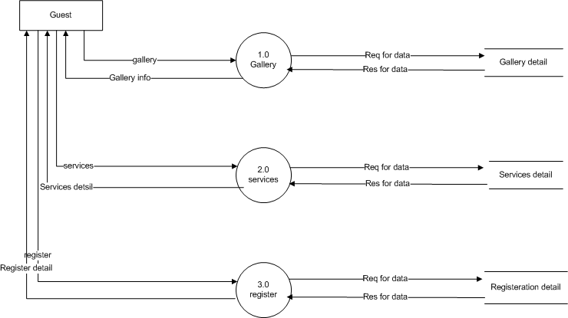

FIGURE 4.10 LEVEL-1 GUEST DFD

LEVEL:2(1)

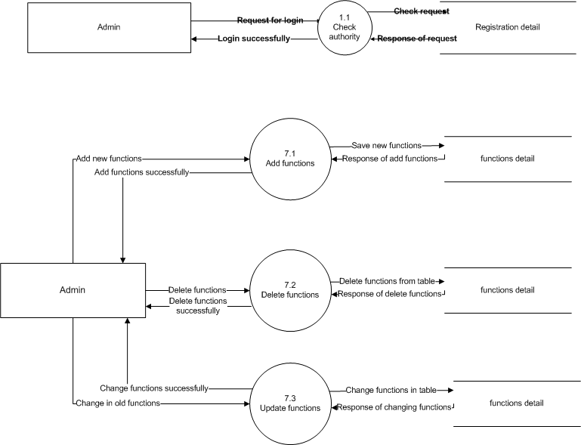

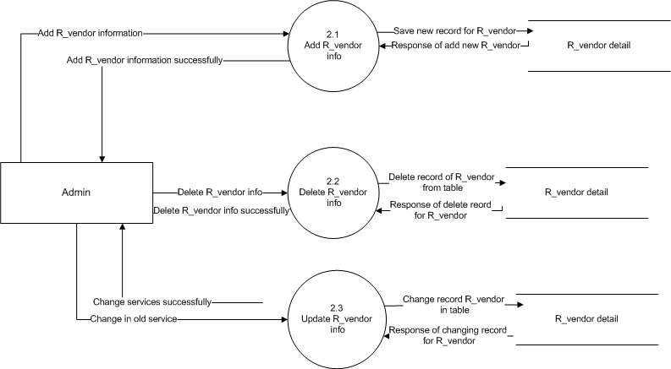

**FIGURE 4.11 LEVEL2 ADMIN DFD**

**LEVEL: 2(2)**

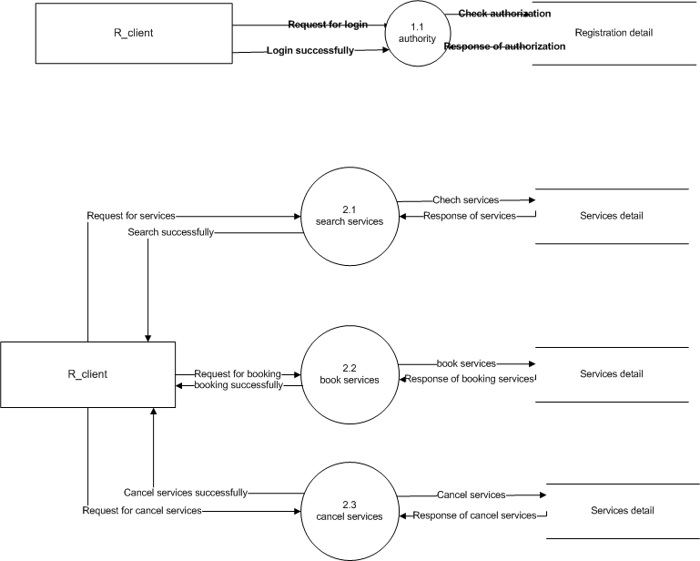

FIGURE 4.12 LEVEL2 R_CLIENT DFD

**LEVEL: 2(3)**

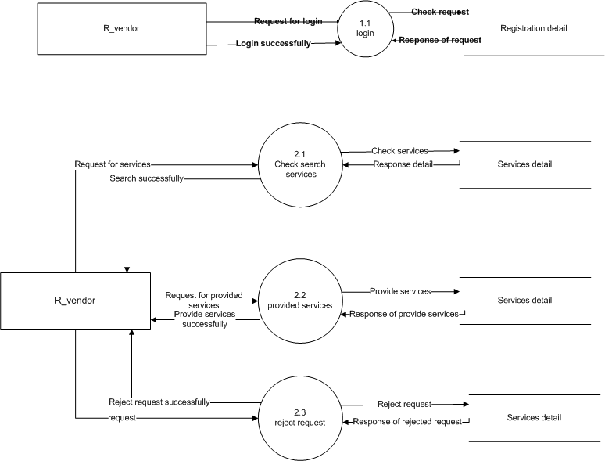



**FIGURE 4.13 LEVEL-2 R_VENDOR DFD**

**4.6.4 SEQUENCE DIAGRAM:-**

**SEQUENCE FOR ADMIN**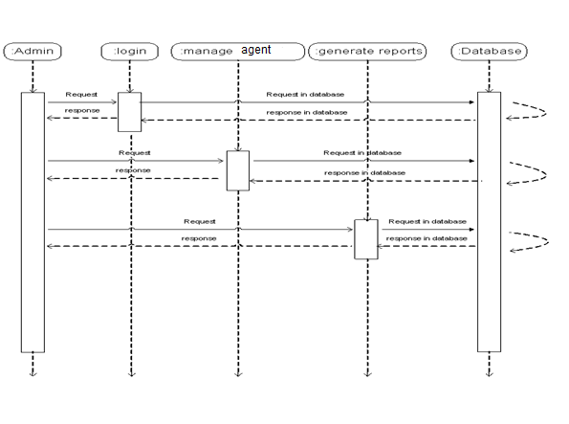

FIGURE 4.14 SEQUENCE FOR ADMIN

SEQUENCE FOR CLIENT

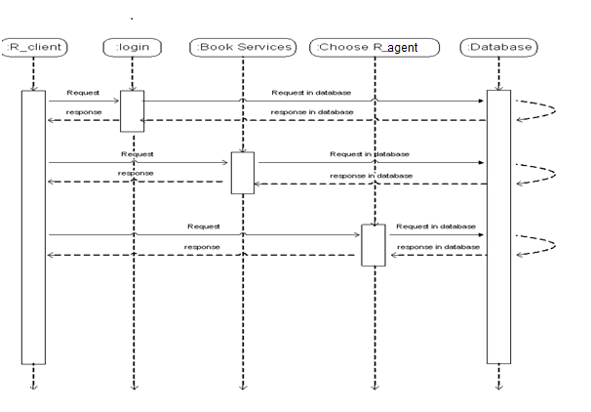

FIGURE 4.15 SEQUENCE FOR CLIENT

**SEQUENCE FOR AGENT**

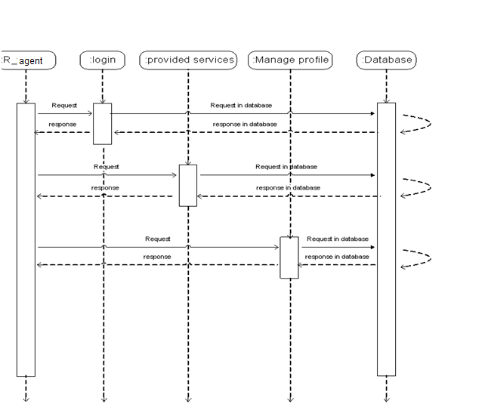

FIGURE 4.16 SEQUENCE FOR AGENT

**SEQUENCE FOR GUEST**

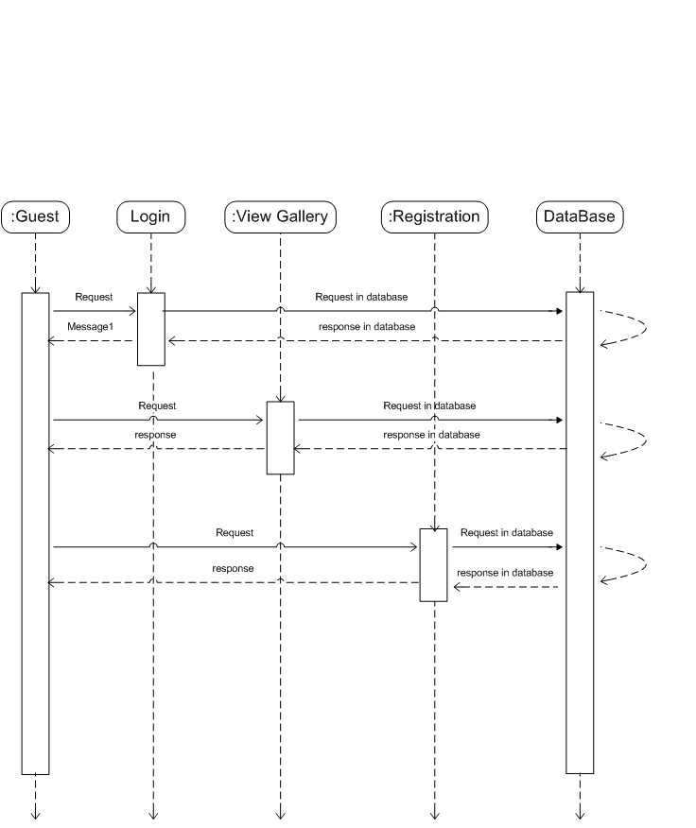

**FIGURE 4.17 SEQUENCE FOR GUEST**

**4.6.5 ACTIVITY DIAGRAM:-**

**ACTIVITY FOR ADMIN**

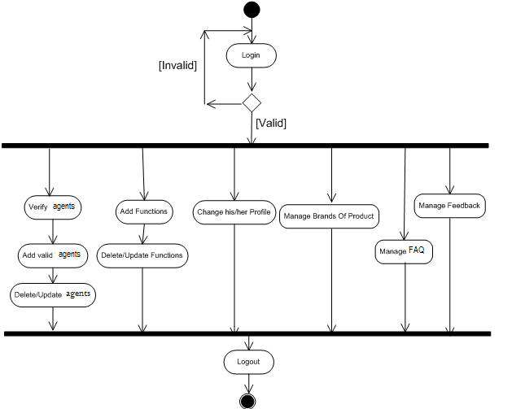

FIGURE 4.18 ACTIVITY DIAGRAM FOR ADMIN

**ACTIVITY FOR CLIENT**

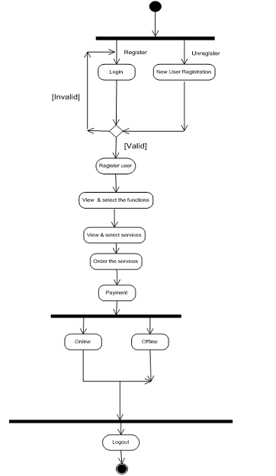

**FIGURE 4.19 ACTIVITY DIAGRAM FOR R_CLIENT**

**ACTIVITY FOR VENDOR (AGENT)**



FIGURE 4.20 ACTIVITY DIAGRAM FOR VENDOR/AGENT

**ACTIVITY FOR VISITOR**



**FIGURE 4.21 ACTIVITY DIAGRAM FOR VISITOR**

**5. System Design**

**5.1 SYSTEM FLOW CHART:**

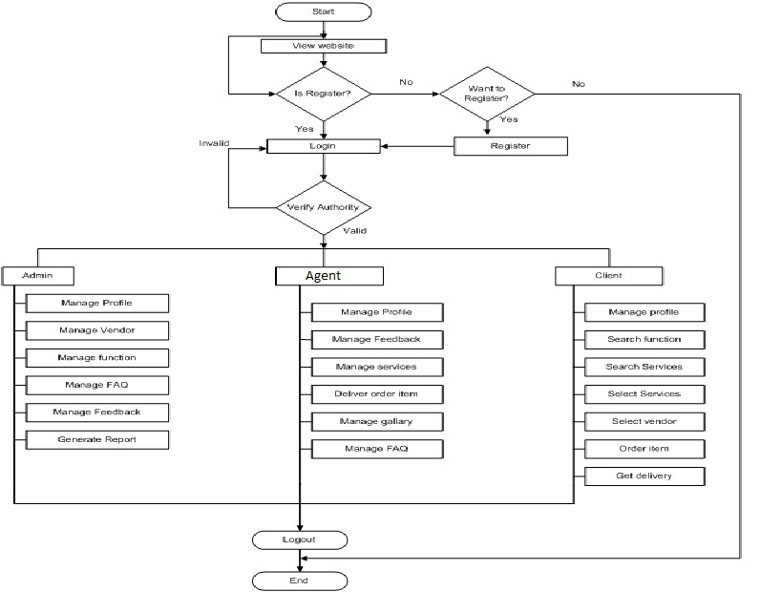

**FIGURE 5.1 SYSTEM FLOW CHART**

**FLOW DIAGRAM EXPLANATION:**

The flow of this system is according to process of manage event. The prototype of system is very simple if it is according to user requirement. The main characters of this system are system admin and customer.

Customer visit the site first as a visitor or guest to get the details about this site. First he or she just view the web site if they want to registered they can login by their user name and password. The admin checked that the entered id and password is right or wrong? After correction of id and password customer can book their order for arranging any event. If authentication is not verified then customers have to login again.

Here admin is very important role in this system it manage profile of site, manage agent for providing different services for fulfill customer requirement and manage event properly according to customer budgets. It manage FAQ so customer can ask any question which they have to know about system n also remove their stress by getting appropriate answers. The customer gives their feedback according to service provided to them. They can give good or bad feedback for the site to admin. Admin can implement their system by user feedback.

Agent is providing here for give different services to the user according to their requirement. For different events, requirements are different so agents are very necessary. They are doing their work effectively and as per the instructions of admin. They arrange event under budget of customer. They also try to do their best for getting good feedback from customer. They also manage the gallery of any event for customer memory.

Customer visits the web site for searching the functions which they require n get services by agents. They select their service and also select agents according to their requirement and their budget. They give their order like which types of decoration, sound system, catering and many other things which they are required. Customer gives their feedback as per the services which they are getting. So by this way flow of system is very easy and useful for customer.

**5.2 DATA DICTIONARY:**

**1. Customer Registration (C_REG):**

|  |  |  |
| --- | --- | --- |
| Field | Data Type | Relation |
|  |  |  |
| SR_NO | Number | Null(Primary Key) |
| F_NAME | VARCHAR2(4000) | Not null |
| L_NAME | VARCHAR2(4000) | Not null |
| GEN | VARCHAR2(4000) | Not null |
| B_DATE | VARCHAR2(4000) | Not null |
| ADDRESS | VARCHAR2(4000) | Not null |
| CONT | VARCHAR2(4000) | Not null |
| STATUS | VARCHAR2(4000) | Null |
| TYPE | VARCHAR2(400) | Not null |
| EMAIL | VARCHAR2(4000) | Not null |
| PASSWORD | VARCHAR2 (4000) | Not null |

**2. Events (EVENTS_TB):**

|  |  |  |
| --- | --- | --- |
| Field | Data Type | Relation |
|  |  |  |
| ID | NUMBER | Null(Primary Key) |
| EVENT_NAME | VARCHAR2(4000) | Not null |
| EVENT_DETAILS | VARCHAR2 (4000) | Not null |
| E_IMAGE | VARCHAR2(4000) | Not null |

**3. Schedule (SCH_TB):**

|  |  |  |  |  |  |
| --- | --- | --- | --- | --- | --- |
| Field | | Data Type | | Relation | |
|  | |  | |  | |
| ID | | Number | | Null(Primary Key) | |
| E_NAME | VARCHAR2(4000) | | Not null | |
| E_VENUE | VARCHAR2(4000) | | Not null | |
| E_DATE | VARCHAR2(4000) | | Not null | |
| E_TIME | VARCHAR2(4000) | | Not null | |
| E_CITY | VARCHAR2(4000) | | Not null | |

**4. Food Details (FOOD_TB):**

|  |  |  |
| --- | --- | --- |
| Field | Data Type | Relation |
|  |  |  |
| STR | VARCHAR2(4000) | Not null |
| INT_F | VARCHAR2(4000) | Not null |
| GUJ_F | VARCHAR2(4000) | Not null |
| CHIN_F | VARCHAR2(4000) | Not null |
| PUN_F | VARCHAR2(4000) | Not null |
| SOU_F | VARCHAR2(4000) | Not null |
| KAT_F | VARCHAR2(4000) | Not null |
| DAS_F | VARCHAR2(4000) | Not null |

**5. Admin (ADMIN_TB):**

|  |  |  |
| --- | --- | --- |
| Field | Data Type | Relation |
|  |  |  |
| USERNAME | VARCHAR2(4000) | Not null |
| PASSWORD | VARCHAR2(4000) | Not null |

**6. about Us (ABOUT_DB):**

|  |  |  |
| --- | --- | --- |
| Field | Data Type | Relation |
|  |  |  |
| ID | NUMBER | Null(Primary Key) |
| DETAILS | VARCHAR2(4000) | Not null |

**7. Booking Details (BOOK_TB):**

|  |  |  |
| --- | --- | --- |
| Field | Data Type | Relation |
|  |  |  |
| SR_NO | Number | Null(Primary Key) |
| PACKAGES | VARCHAR2(4000) | Not null |
| VENUE | VARCHAR2(4000) | Not null |
| DECORATION | VARCHAR2(4000) | Not null |
| FOOD | VARCHAR2(4000) | Not null |
| MUSIC | VARCHAR2(4000) | Not null |
| E_DATE | VARCHAR2(4000)) | Not null |
| EVENTS | VARCHAR2(4000) | Not null |

**8. Music Details (MUSIC_TB):**

|  |  |  |
| --- | --- | --- |
| Field | Data Type | Relation |
|  |  |  |
| Type | VARCHAR2(4000) | Not null |
| Price | VARCHAR2(4000) | Not null |

**9. Packages Details (PACKAGES_TB):**

|  |  |  |
| --- | --- | --- |
| Field | Data Type | Relation |
|  |  |  |
| M_PL_DE | VARCHAR2(4000) | Not null |
| M_PL_RS | VARCHAR2(4000) | Not null |
| M_GO_DE | VARCHAR2(4000) | Not null |
| M_GO_RS | VARCHAR2(4000) | Not null |
| M_SI_DE | VARCHAR2(4000) | Not null |
| M_SI_RS | VARCHAR2(4000) | Not null |
| B_PL_DE | VARCHAR2(4000) | Not null |
| B_PL_RS | VARCHAR2(4000) | Not null |
| B_GO_DE | VARCHAR2(4000) | Not null |
| B_GO_RS | VARCHAR2(4000) | Not null |
| B_SI_DE | VARCHAR2(4000) | Not null |
| B_SI_RS | VARCHAR2(4000) | Not null |
| G_PL_DE | VARCHAR2(4000) | Not null |
| G_PL_RS | VARCHAR2(4000) | Not null |
| G_GO_DE | VARCHAR2(4000) | Not null |
| G_GO_RS | VARCHAR2(4000) | Not null |
| G_SI_DE | VARCHAR2(4000) | Not null |
| G_SI_RS | VARCHAR2(4000) | Not null |

**10. Title (TITLE_TB);**

|  |  |  |
| --- | --- | --- |
| Field | Data Type | Relation |
|  |  |  |
| CLIENT_T | VARCHAR2(4000) | Not null |
| ADMIN_T | VARCHAR2(4000) | Not null |

**11. Decoration Services (DECO_TB):**

|  |  |  |
| --- | --- | --- |
| Field | Data Type | Relation |
|  |  |  |
| MRG_D | VARCHAR2(4000) | Not null |
| BDAY_D | VARCHAR2(4000) | Not null |
| GET_D | VARCHAR2(4000) | Not null |

**12. Contact (CONTACT_TB):**

|  |  |  |
| --- | --- | --- |
| Field | Data Type | Relation |
|  |  |  |
| NAME | VARCHAR2(4000) | Null(Primary Key) |
| ADDRESS | VARCHAR2(4000) | Not null |
| CONTACT | VARCHAR2(4000) | Not null |
| EMAIL | VARCHAR2(4000) | Not null |
| FAX | VARCHAR2(4000) | Not null |
| WEBSITE | VARCHAR2(4000) | Not null |

**13. Feedback (FEEDBACK_TB):**

|  |  |  |  |  |  |
| --- | --- | --- | --- | --- | --- |
| Field | | Data Type | | Relation | |
|  | |  | |  | |
| ID | | NUMBER | | Null(Primary Key) | |
| F_NAME | VARCHAR2(4000) | | Not null | |
| F_EMAIL | VARCHAR2(4000) | | Not null | |
| F_PHONE | VARCHAR2(4000) | | Not null | |
| F_MESSAGE | VARCHAR2(4000) | | Not null, | |

**6. User Interface View:**

**6.1 CLIENT PANEL VIEW:**

* **Home page :**

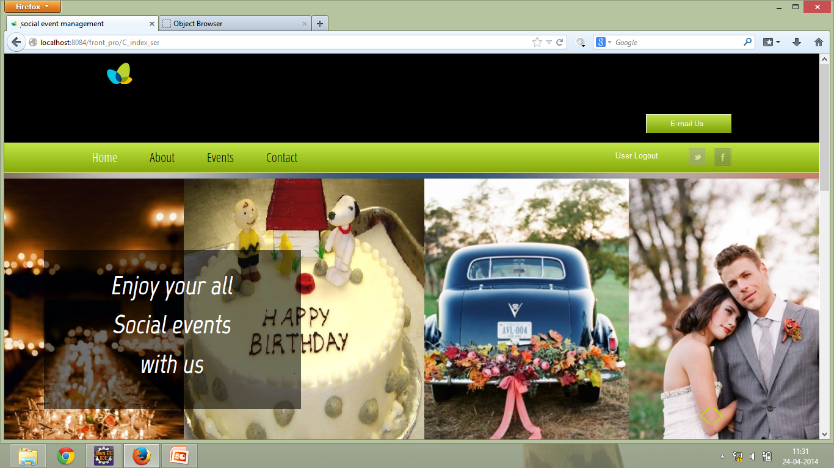

* From here you can go to any page.
* Link all the pages almost Login, Register, About, Contact, Events.
* **About Us page :**

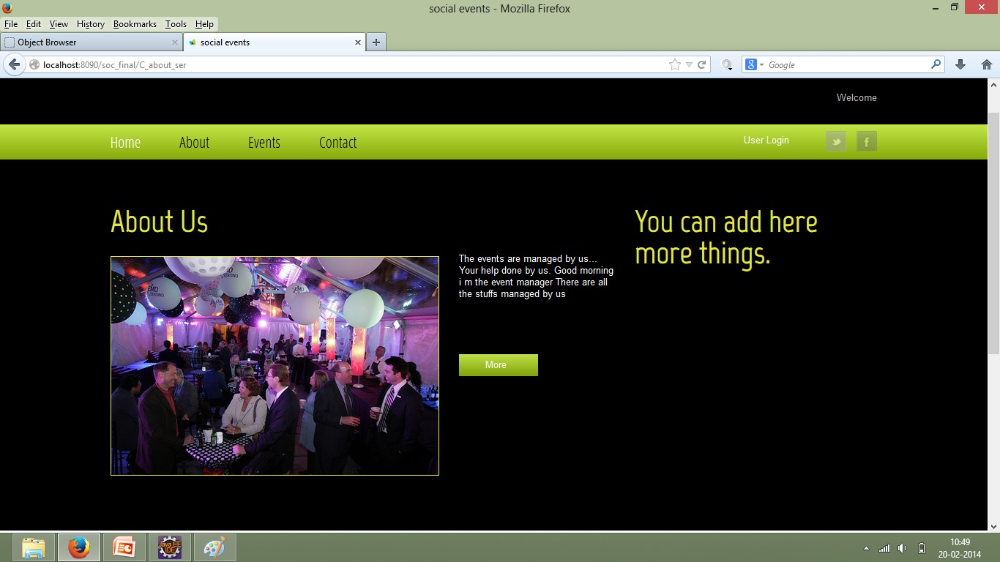

* This page is of about admin detail.
* Client can view all details about admin.
* This page is interact with database.
* **Client Registration :**

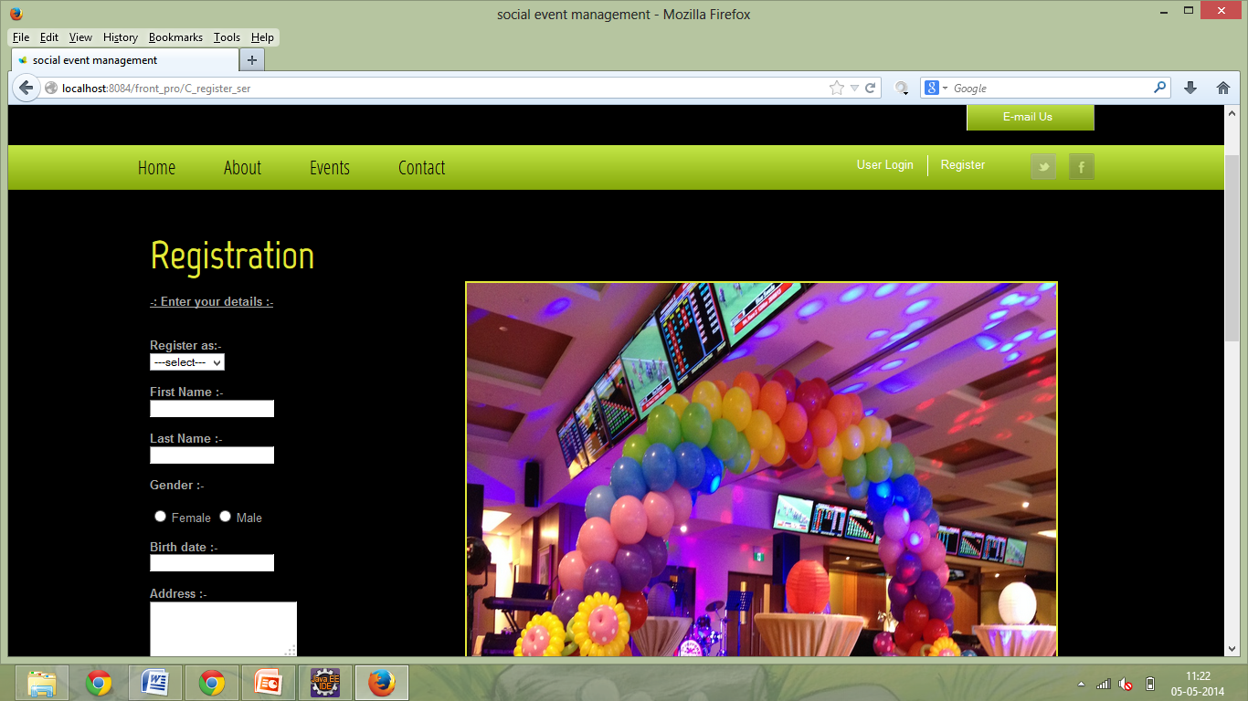

* This page is for registration.
* Client and agents can register.
* Id and password will be provided by registration form.
* **Variety details page :**

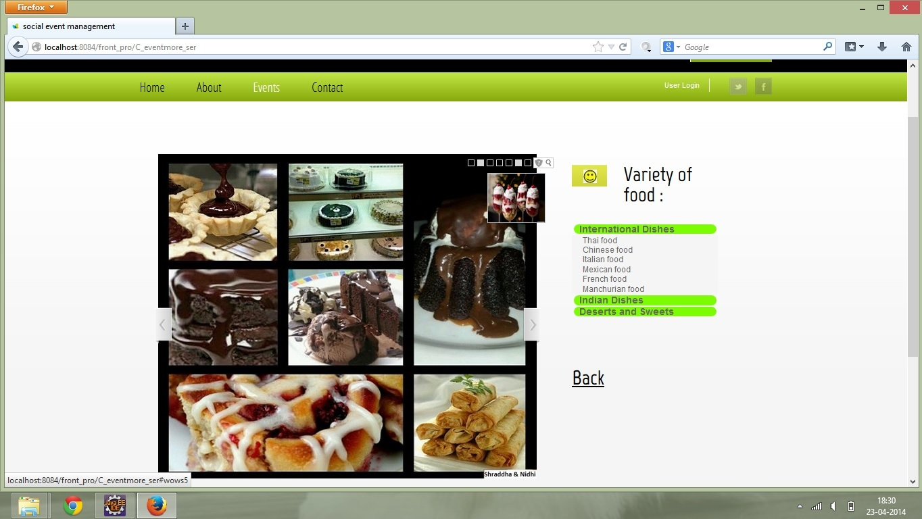

* There are variety can view through the accordion.
* When you click to the title its information will open below it.
* **Events page :**

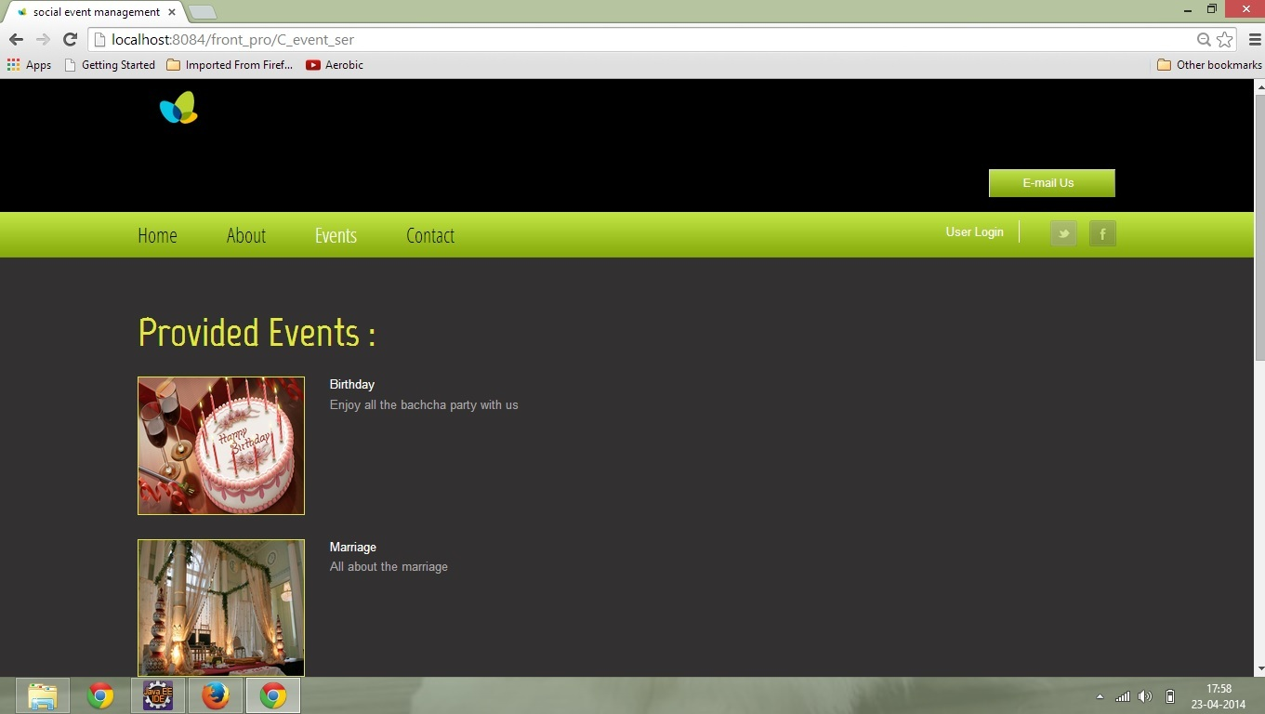

* Events inserted from admin side is shown here.
* Event with uploaded photo is visible.
* By clicking on any of event the varieties of foods and locations.
* **Login page :**

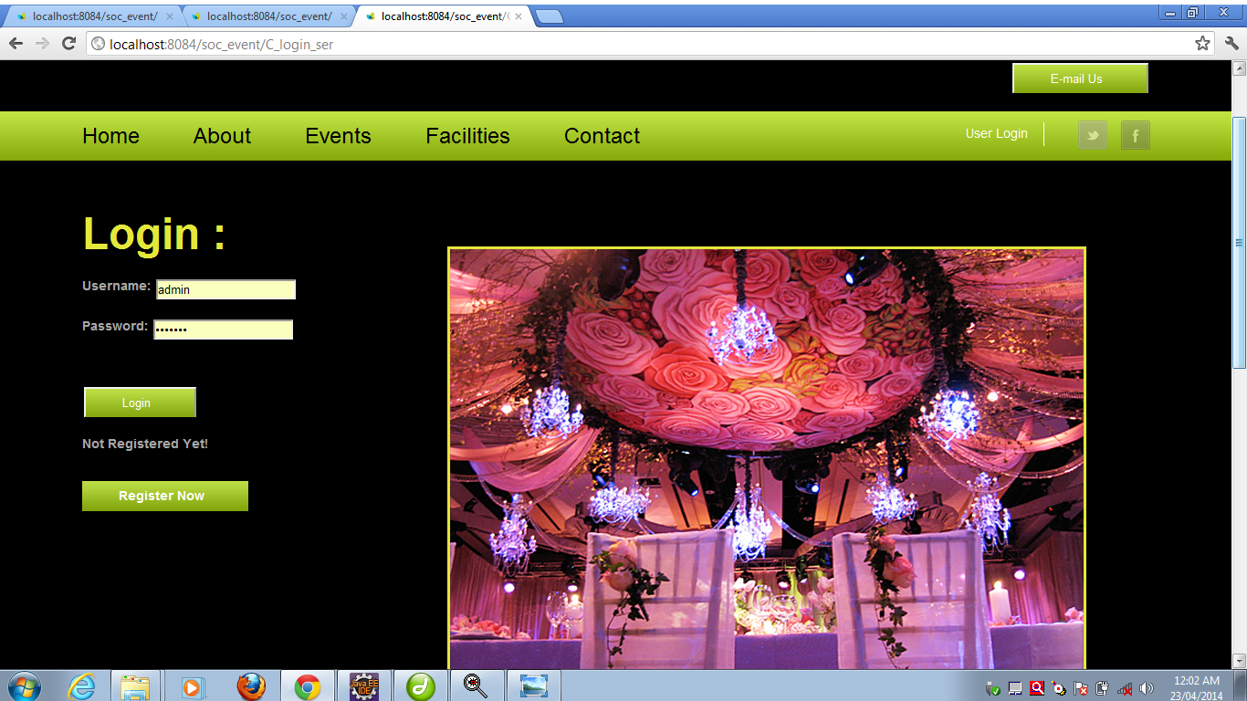

* Client can login via this page.
* He or she can enjoy booking and facilities given to our clients.
* **Client profile page :**

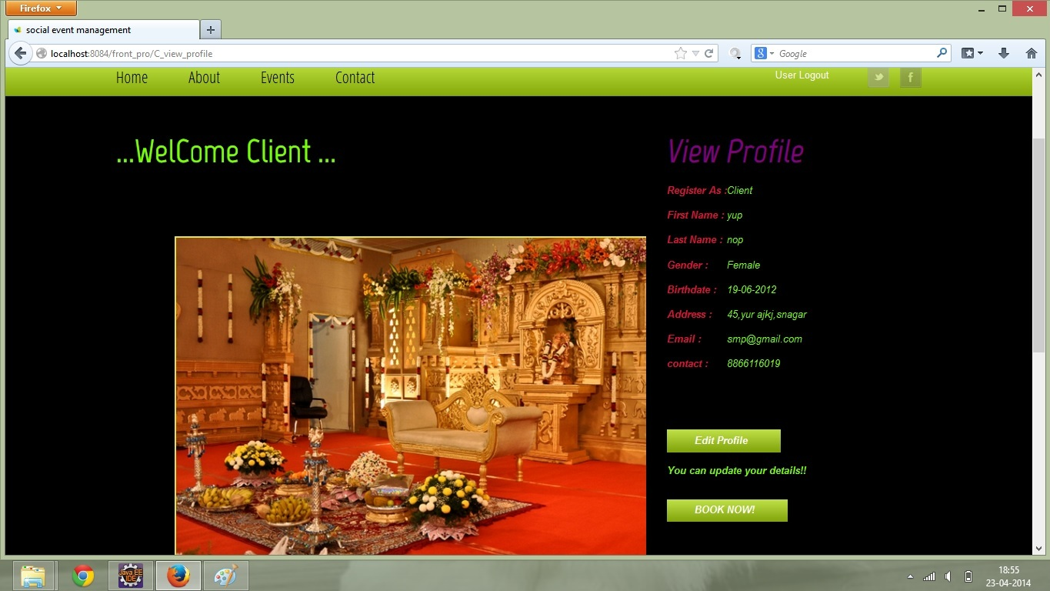

* Via login if u click on view profile then your information which you have registered will show.
* The data entered you can view and by edit profile link you can go to edit page
* **Client edit profile page :**

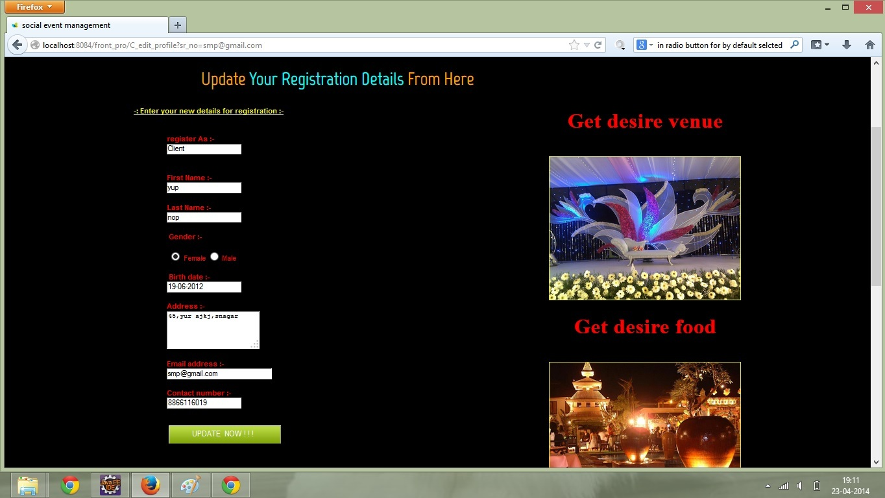

* Client can update his or her profile by this page.
* **Contact us & Feedback page :**

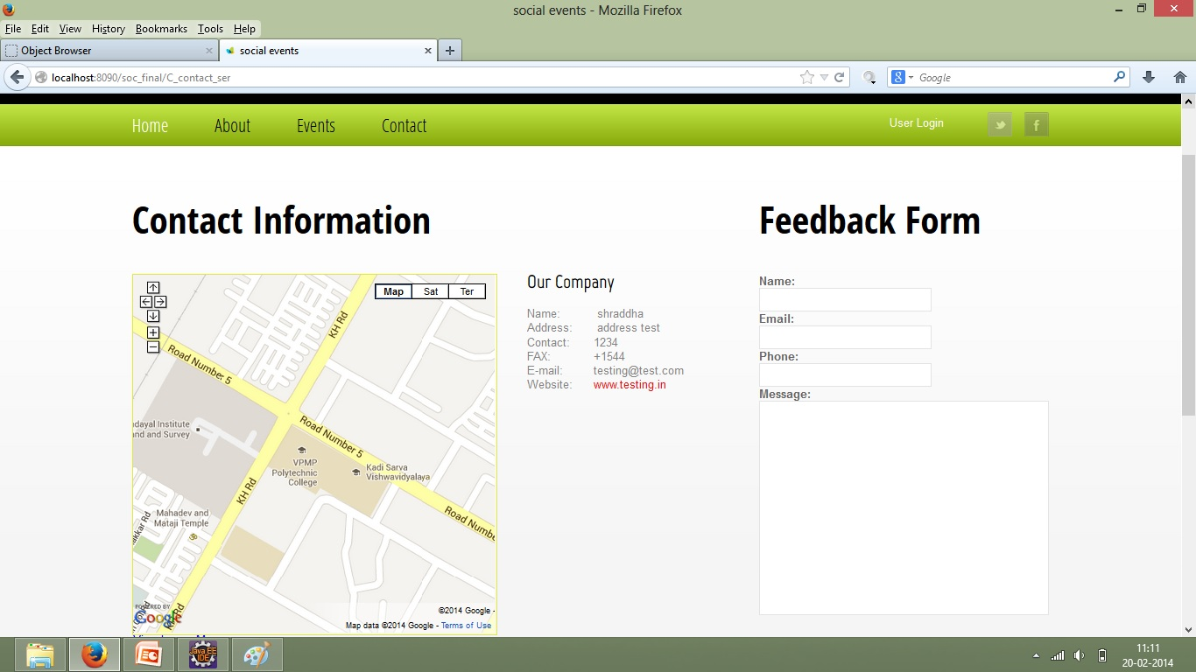

* From this page the user can give feedback from here.
* And our address added from client side is being viewed here.
* **Tips and ideas page :**

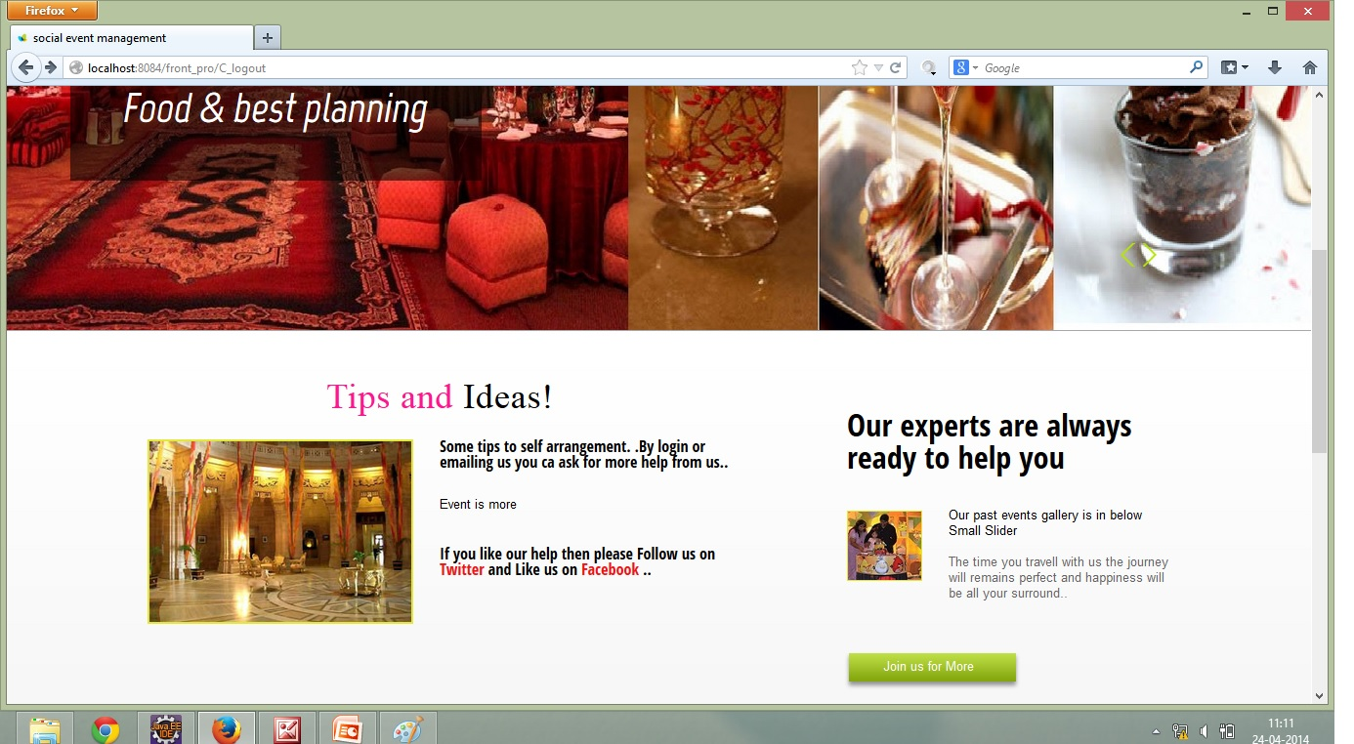

* Admin provides tips & ideas to clients to arranged events**.**

**6.1 ADMIN PANEL VIEW:**

* **Admin login page :**

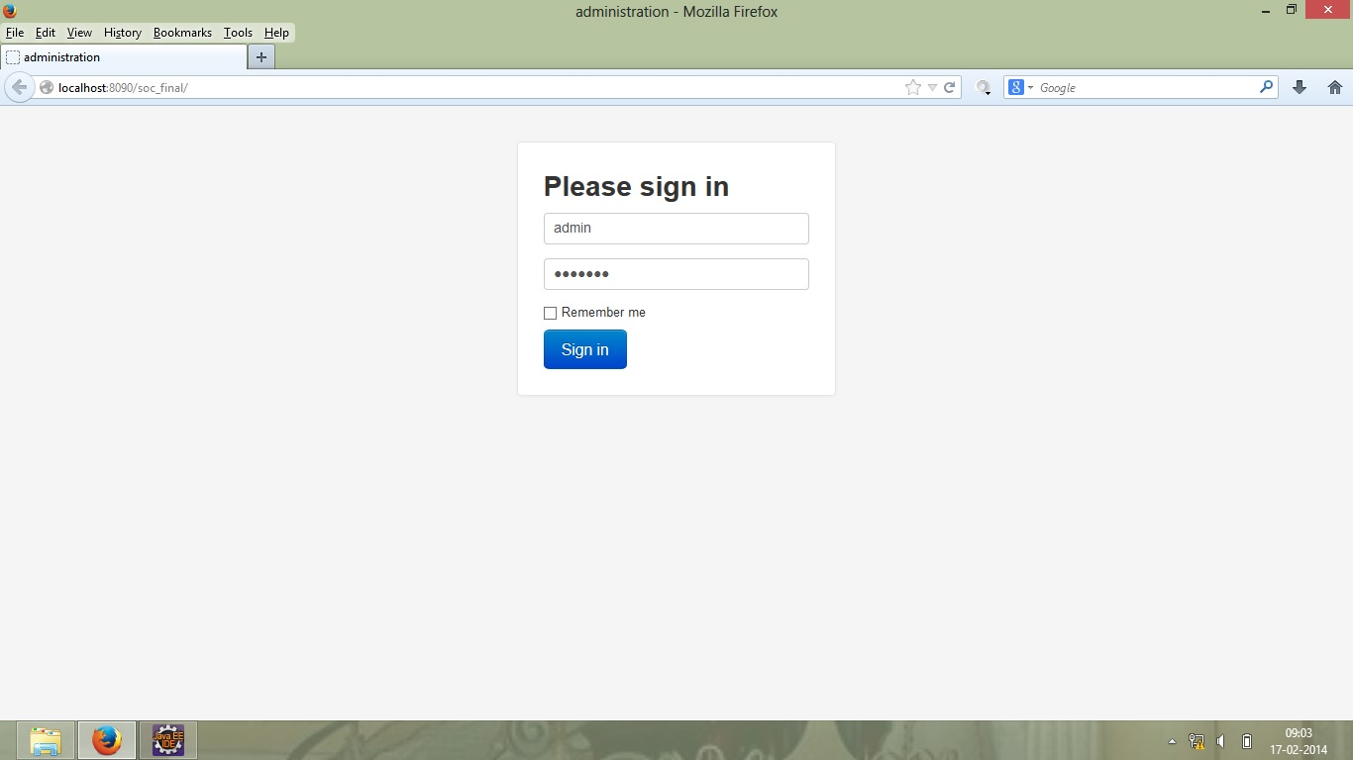

* **Whenever admin entered password and id it is verified if user is authenticated then it allows to login into admin panel.**
* **This page can only accessed by admin.**
* **Admin index page :**

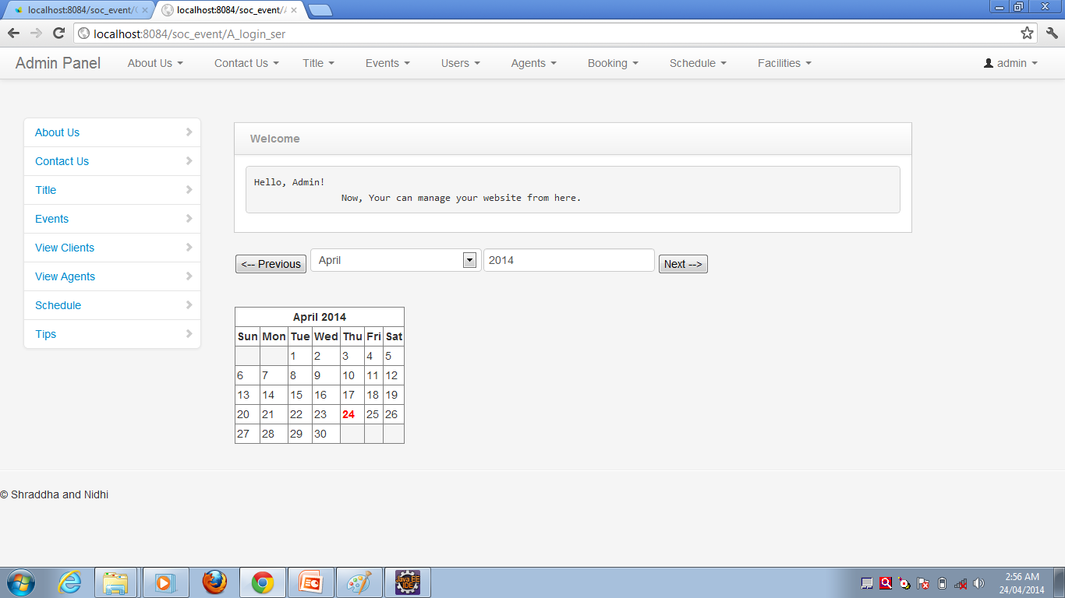

* **This is the welcome page of admin panel.**
* **All other pages are linked with this page.**
* **About us view page :**

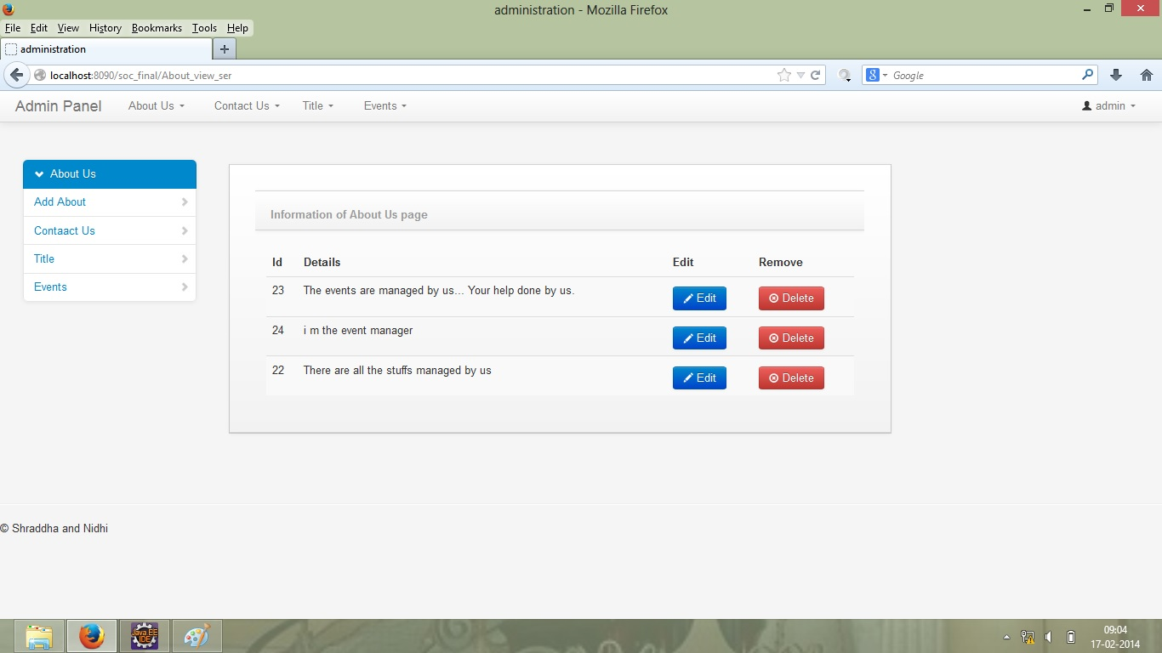

* **This page is of admin information.**
* **Admin canniest all necessary information.**
* **This page is interacted with database.**
* **Anything which is posted in this page, it can be viewed in about page of client.**
* **Contact us details edit page :**

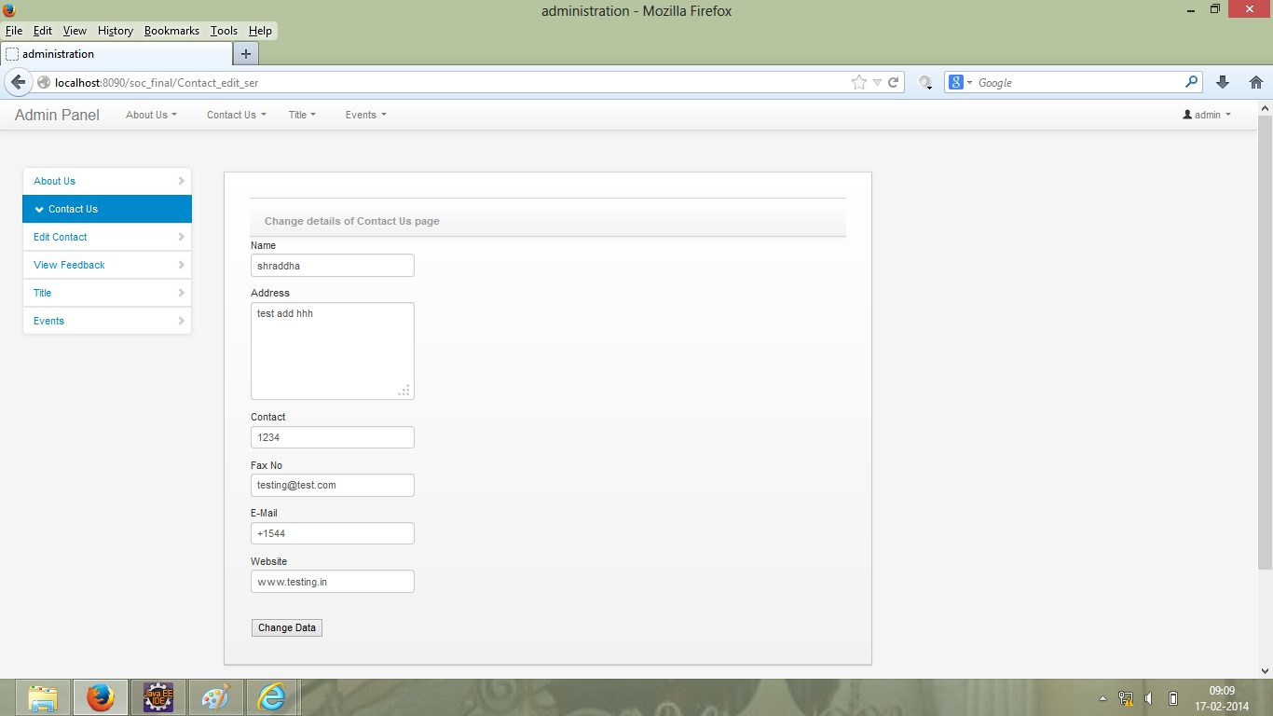

* **Admin can update one's contact using this page.**
* **Which will be posted on Contact us page at client side.**
* **Add event detail page :**

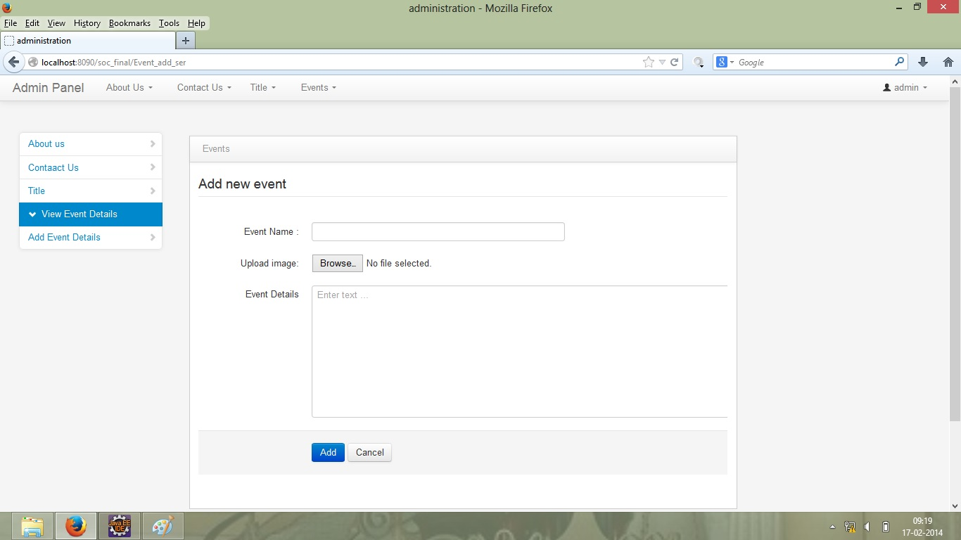

**All the events which are organized by admin are viewed in this page.**

**Also the pictures of events are also posted in this page.**

**All events are stored in database.**

**It is also interacted with database.**

* **Feedback view page :**

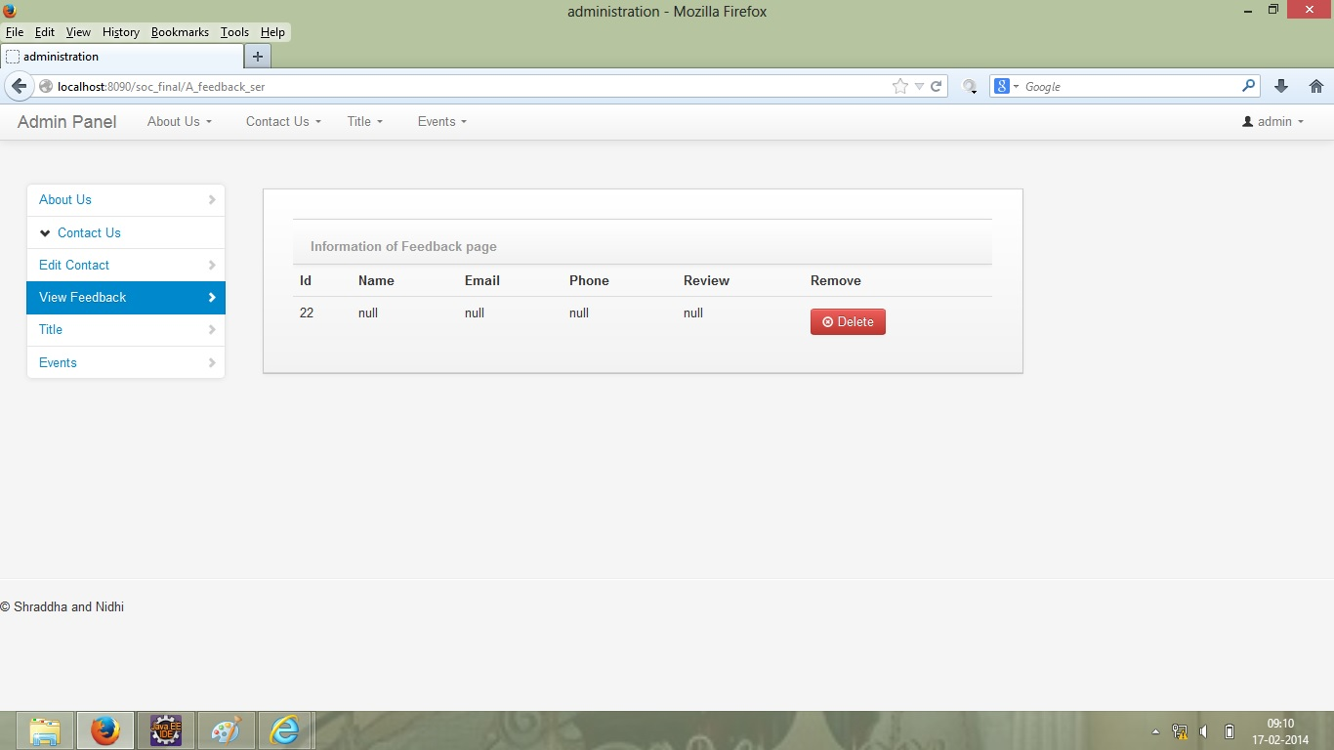

* **By this page admin can see the feedback which are given by client.**
* **Admin can also delete the feedback.**
* **View registered clients page :**

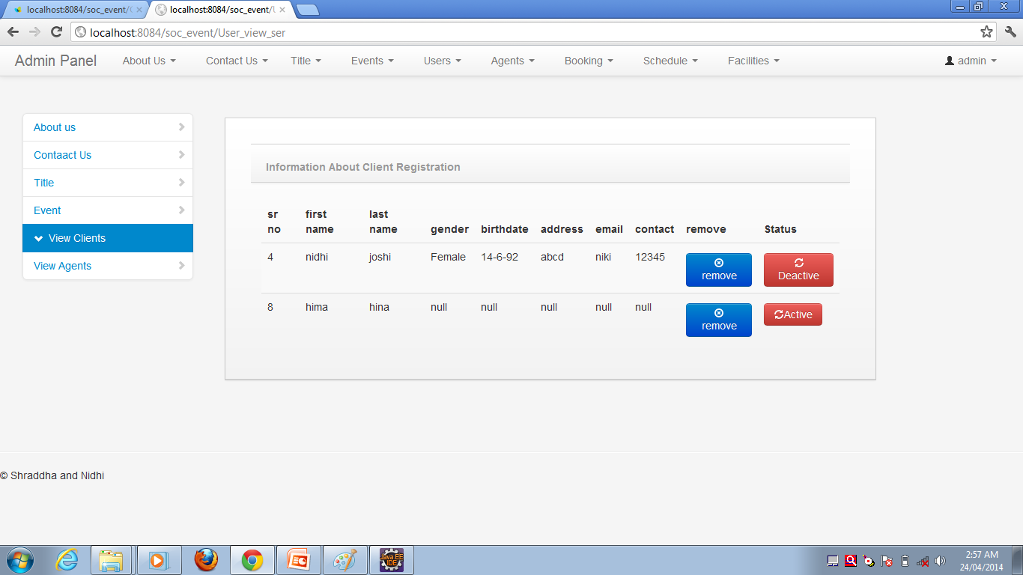

* **Admin can view the registered users, agents & visitors.**
* **Also active & de-active them.**
* **Client booking details page :**

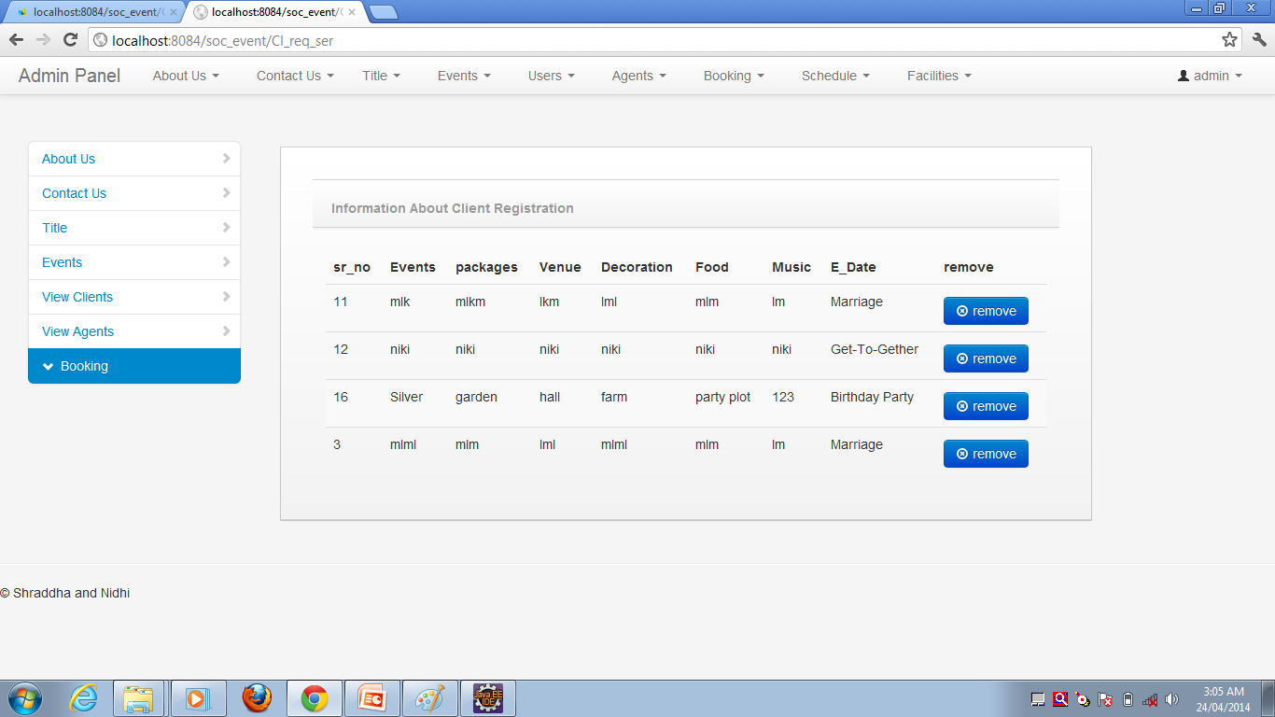

* **Admin can view the client booking.**
* **This page is also interact with database.**

**7. Drawbacks and Future enhancement:**

* **Drawbacks:-**

1) No automatic backup facilities available.

2) To run the application Internet Explorer 5.0 and above is required.

* **Future Enhancement:-**

1) Data backup facility will be introduced.

2) Graphical richness is required for the more user interactivity.

**8. Conclusion**

* Social Event management is converging towards a systematic approach to planning and control.
* The complexity and increasingly regulated environment requires some standardization.
* This system provides solution to all problem which are related to social events.
* The service of tips solves confusion of people.
* The dynamic system that provide easy way to manage social events.

**9. Bibliography**

1. Pressman, Roger S., “Software Engineering “A practitioner’s Approach”, Fifth Edition, McGraw-Hill, 2000.
2. http://www.atilim.edu.tr/~dmishra/se112/sampleSRS.pdf
3. J Thomas Monk , "Software Analysis And Development
4. D.H. Bailey, J. Borwein , P.B. Borwein , S. Plouffe, The quest for Pi, Math.
5. http://www.bing.com
6. http://www.google.com